Guidelines for Course Archive Updates

# Overall Structure

**Where is the archive?**

The Course Archive could be found on a network drive **EE-Common$ (****\\eng-fs0.eng.uab.edu****)** in the folder **CourseArchive**. If your computer is wired to the UAB network, you should have access to this drive in your Windows File Explorer. If your computer connects through WiFi to the UAB Secure network, you will need to install the Cisco AnyConnect VPN Client (instructions: <https://www.uab.edu/it/home/tech-solutions/network/vpn>) and then map the network drive above (instructions: <https://support.microsoft.com/en-us/windows/map-a-network-drive-in-windows-29ce55d1-34e3-a7e2-4801-131475f9557d>). Please contact engineering IT team if you need any help with installing the network drive.

**Where is my course?**

Once you have access to the **EE-Common** drive, go to the folder CourseArchive and then the appropriate year and semester folder. Find a folder with your course number (e.g., EE318). There you will store all your ABET-related data.

**Overall folder structure**

Inside your course folder, you will find two more folders: Handouts and Work_Products. DO NOT DELETE THESE FOLDERS!

The folder structure in **Figure 1** is required for automated validation of folder contents.

* In the main course folder, there MUST be a file named **Syllabus.pdf** (*all file and folder names are not case sensitive*)
* It is highly improbable that through your course students never received any printed or electronic handouts. Therefore, some files are expected to be available in the **Handouts** folder. Do not create additional sub-folders inside the **Handouts** folder. If you want to group multiple handouts, use ZIP files.
* Inside the **Work_Products** folder, each assignment or test should have its own sub-folder (you are free to choose any appropriate name). Each sub-folder should include 3 files (and optionally the assignment/test description file):
  + S1 – an example of a very good/excellent representative work
  + S2 – an example of a good/okay representative work
  + S3 – an example of a low-quality representative work
* If you want to group multiple files in a single assignment, you could submit them as S1.zip, etc.
* Do not forget to have student’s name and their grade to be present at the top of each submitted assignment/test. You also want some feedback for students to be available in these submitted documents.
* Optionally, you can export the Canvas gradebook (CSV file with an automatically generated name) to the **Work_Products** folder. This will allow showing results of quizzes and other graded assignments that were not included in separate folders.

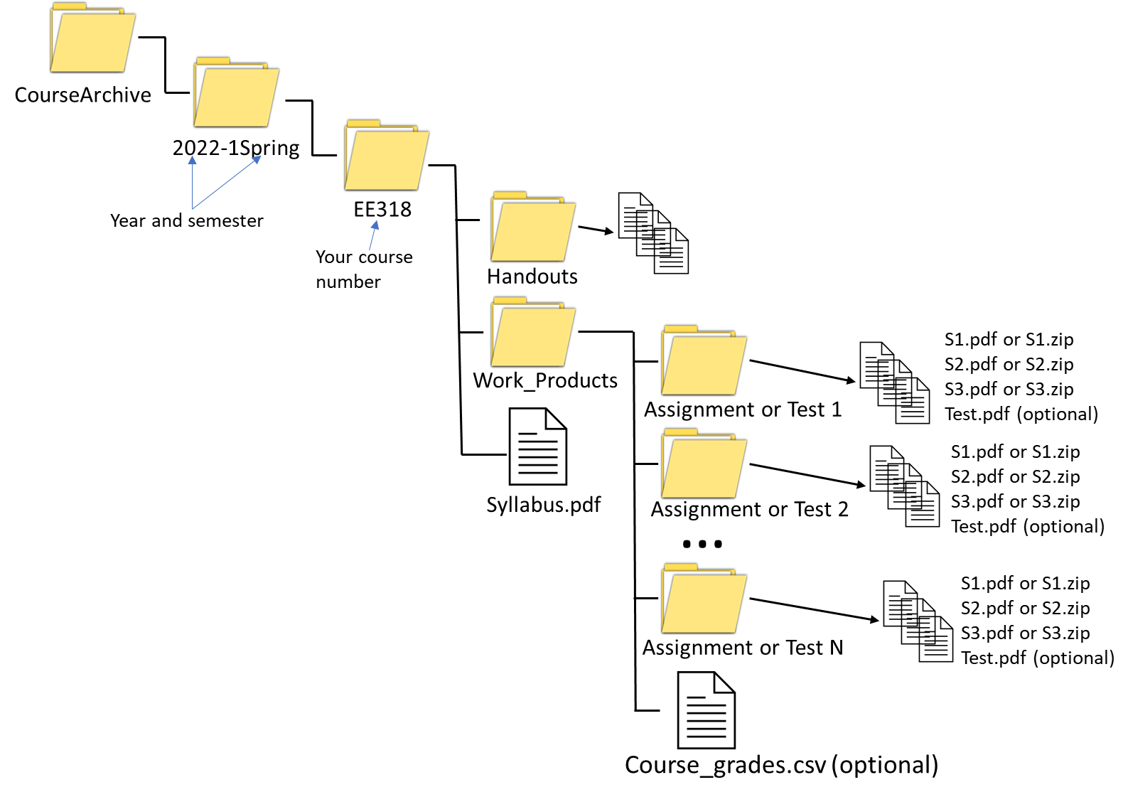

Figure 1 Course Archive Folder Structure

**I am still confused. What should I do?**

There is an open-source interactive course archive validator software that is available to you. This software helps to identify issues with your folder/file structure and describes potential ways to resolve the issues.

Do not hesitate to contact Dr. Jololian ([leon@uab.edu](mailto:leon@uab.edu)) or Dr. Nakhmani ([anry@uab.edu](mailto:anry@uab.edu)) if you have any questions or concerns.